**Internal documents**

**Team documentation**

**Team documentation helps clarify the work in progress so that the team can work as a team. These documents take the form of project plans, team schedules, status reports, meeting minutes, and any other content that the team may need to work functionally and efficiently. Such documents are detailed to ensure that everyone stays on the same page.**

**Reference documents**

**Reference documents educate the company on important topics, processes and policies. These may be policies formulated by the human resources department, legal procedures for hiring external suppliers, or articles on the operation methods of establishing company benefits. Remember that reference documents are written by a small group of people for a large and diverse audience, so digestible content is important.**

**Project documents are naturally project specific and provide a much-needed structure for product development. It includes proposals, product requirements documents, design guidelines or sketches, road maps and other relevant information required for development, which has been contributed by project managers, engineers, designers, etc.**

**External documents**

**The system documentation describes the code, API and other processes in detail. These processes tell developers and programmers what methods and functions can be used when developing specific software, as well as limitations and requirements. Code snippets, such as sample API calls and responses, are at the heart of such documents.**

**User documents are usually the most obvious document type. It should be easy to read and understand and updated with each new version of the software. It appears in the form of "read me" documents, installation guides, management guides, product knowledge bases and tutorials (among which the most helpful ones). And, like reference documents, it is produced by a small group of creators, so digestible content is important for a large group of consumers**

**Select technical documentation software solution**

**In addition to reviewing solutions that support different document types, note these selection criteria.**

**Pricing plan: the technical documentation software solution usually comes with a monthly billing plan for each user, with the upper limit of storage limit and page views. When you have a large support team and get a lot of hits, these will soon become a problem, and these hits can accumulate quickly.**

**Good access control: your technical documents are usually a mixture of private and public parts. Therefore, your technical documentation software should have at least a certain degree of access control.**

**Comfortable writing and editing experience: of course, you need good writing and editing experience, which your technical writers and other team members like.**

**I choose**

**[HelpNDoc](https://www.helpndoc.com/" \t "/Users/amy/Documents\\x/_blank)**

HelpNDoc is another help authoring tool that lets you create technical documentation. This is a downloadable software that you can use with Windows only. Once you write your documentation with HelpNDoc, you can export it to host on your servers.

**Comes with an editing experience similar to Microsoft Work with all the formatting options showing neatly using the “ribbon” design.**

**Offers a media library so you can add your pictures, videos, attachments, etc.**

**Offers several export options to convert your technical documentation into websites, PDFs, Kindle eBooks, and more.**

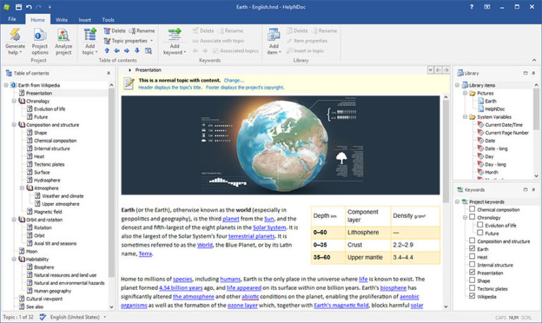

**Advice：Then why should I care?**

**At its simplest, documentation can help people do what they need to do. But, like most inexplicable and extraordinary things, it's not just about helping people get money.**

**Documentation helps users and teams:**

**Consume less mental energy**

**Work can be done without too much thought and as little effort as possible.**

**Create consistency**

**Ensure that your readers use the same information, processes, and plans in a consistent manner.**

**Minimize workload**

**Teammates on the plane are fast and efficient so that they can start to finish their work immediately.**